Tuesday 26th February 2019
BUYA have pleasure in inviting you to enter teams into our 9-A-Side Tournament.
Date: Saturday 25th May 2019
9.00am to 1.00pm 2008 (Cup and Plate. guaranteed at least 4 x 20 min games)
1.30pm to 5.45pm 2007 (Cup and Plate. guaranteed at least 4 x 20 min games)
Venue : Joey Dunlop Leisure Centre Stadium Ballymoney
Overview of rules

Address
36 Millgrange,
Ballymoney
County Antrim
BT53 7QB

Organiser
Simon Smyth

Phone
07725314801

Email
simon@ballymoneyyouthacademy.co.uk

Web
www.ballymoneyyouthacademy.co.uk
• Teams will consist of 9 players and 5 substitutes (maximum).
• Entries will be allocated on a first come, first served basis.
• Entry cost is £40 per team. Please note refunds cannot be made once your entry is confirmed. Entry confirmation will be done through email.
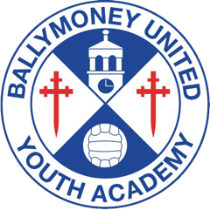
• All players to be in their respective age groups as per 2018/2019 football season. Please make sure you have relevant photographic ID for all your players (you may be required to show this in the event of a query).

Ballymoney United Youth Academy
• Player Registration forms and rules pack will be sent out nearer to the date of the Competition via email.
If you wish to enter teams into the KRD Tournament please complete and return the form below with your cheque made payable to: Ballymoney United Youth Academy
Yours sincerely
Simon

Club Name​​: _______________________. Age Group: _______​​
Club Contact​​​​ _______________________
Contact Number:_______________________

BUYA KRD Entry Form
Email: __________________________________________________

Rules and registration forms will be sent out by email.

